St Patrick’s College, Silverstream Foundation

Invites you: 87th 1st XV Traditional vs Wellington College @Silverstream

Game kicks off 1.30pm

Wednesday 6 June 2018 – Bar open from 12 00noon
Lunch $10 Drinks $5

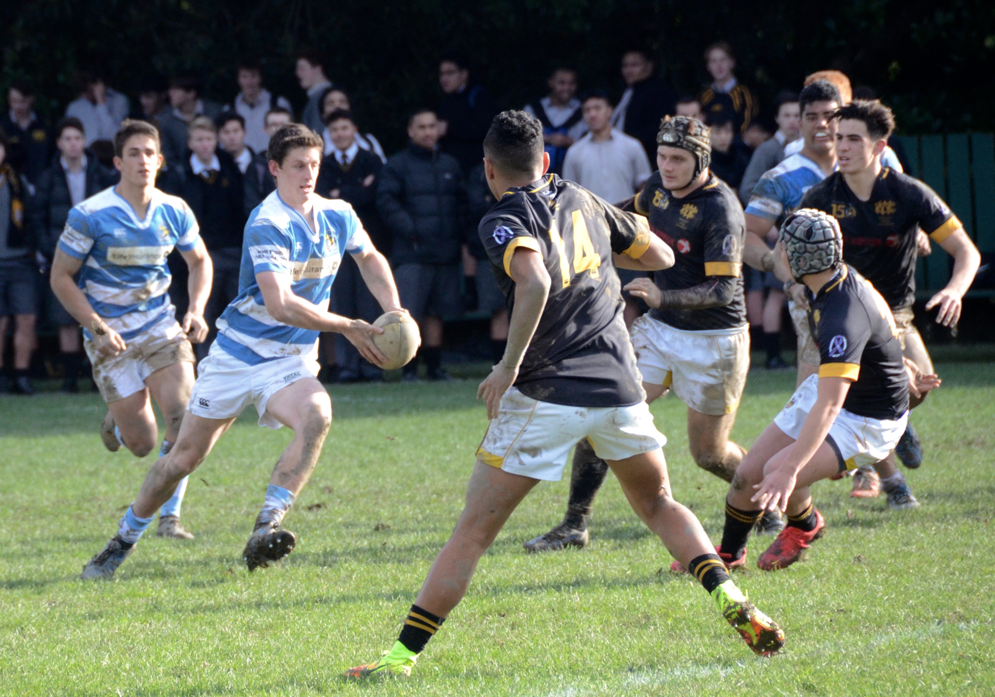

Supported by Trentham Mess Hall

RSVP by Friday 1 June to: foundation@stream.school.nz
021615369 – Mike O’Leary
Numbers required for catering

